Oleksandr Yardas
TUT-100-17
Paul Hutchison
10/08/2016
Monsters
Monsters are personal things; they are creatures that embody the fears, insecurities, and desires of an individual. For every person, purpose is the monster that looms greatest of all. To have a purpose is to have a life. Without a purpose, one’s life is meaningless, and vice versa. In the comic strip Calvin and Hobbes, monsters are a recurring theme that take the form of beings who reside under Calvin’s bed, taunting and terrifying him. The author of Calvin and Hobbes, Bill Watterson, was unemployed several months after he graduated college, and for several years was floating through life, unsure of where his path lay, stuck and unable to get free. Metaphorically speaking, the longer you float, the harder it is to swim, and for many people, they being to think that floating is their purpose. Only by conquering the monsters that threaten you can you swim free. For Watterson this was and remains true, and is represented in his comic by the monsters under Calvin’s bed.
Bill Watterson’s monster was separation from reading and writing comics. Watterson was exposed to comics at a young age. He grew up reading strips that inspired him to make comics of his own. At Kenyon College, he was drawn to pursuing political cartooning as a career when he noted the success of a recent Kenyon alumn who did political cartooning for the Cincinnati Post (Watterson, Complete C&H, Vol 1, 7). Watterson had never been keyed-in to politics, but the prospect of having a career doing something he loved pushed him to major in Political Science and applied for a job at the Cincinnati Post doing political cartoons (Complete, Vol 1, 7). However in an interview, Watterson said that he was “self-deluded about doing political cartoons,” and that he thought he could “muscle his way through it” (Watterson, Exploring C&H, 8). Things are clearer in hindsight, and Watterson was unable to see at the time that this was not his passion. He was eventually hired by the Cincinnati Post in what he called a “freak twist of bad fate,” (Complete, Vol 1, 8) and only months later he was fired for consistently producing unpublishable content. Watterson had met his monster and fallen to it.
What at first appeared to be a dream job turned out to be a nightmare. He had lost the battle for now, and had to get a real job, which he defined as “a job that you hate.” (Watterson, “Thoughts on the real world”). This meant he was neither reading nor writing comic strips. He was blind and mute, unable to read, write, and speak “the language [he] grew up speaking.” (Exploring, 8). He was stuck in a job he hated, doing things that wasted his time for several years. His purpose was threatened at this point in his life.
The monsters under Calvin’s bed represent the threat of a lack of purpose. Calvin is woken up by the monsters who are pretending to be his mom (Figure 1, Watterson, Complete C&H, Vol 3, 312). In his confused waking state, he is almost taken by the monsters due to their deception, but jolts awake just in time to realize that the voice is not his mothers, and is indeed a monster’s. Calvin talks to his mother and she tells him that he needs to ignore the monsters (Figure 2, Watterson, Complete C&H, Vol 3, 312). Much like Watterson being stuck in a job that he hates, cut off from his dream, Calvin is stuck with literal monsters constantly looming under him. They are a constant threat, a reminder of the façade of safety and security that life takes on. They are a threat to his purpose in their schemes to kill him and in making Calvin reflect on his own mortality (Figure 3, Watterson, Complete C&H, Vol 3, 313). Ignoring monsters is not enough to stop them, and this is shown in the attitude of Calvin’s mother, who faced and succumbed to her own monsters of purpose, and is permanently stuck raising a six-year old child. She ignores the fact that she could have done other things because that reality is too painful to imagine in her current one, so she ignores it. To stop monsters, one must conquer them.
Watterson was able to conquer his monsters because he held on to his dream. He didn’t give up as many other people in the same situation often do. In 1990 Watterson addressed the graduating class of Kenyon College: “In the middle of my sophomore year at Kenyon, I decided to paint a copy of Michelangelo's ‘Creation of Adam’ from the Sistine Chapel on the ceiling of my dorm room” (Watterson, “Thoughts on the real world,” 1). The painting took months of work, and it was only after he completed the painting near the end of the academic year that he asked for approval from the housing director. In the end, he “never spent as much time or work on any art project, or any poly sci paper, as [he] spent on this one act of vandalism” (Watterson, “Thoughts,” 1). The work that we do for ourselves is often the most rewarding, so we work harder and longer on things that catch our interest than any assigned piece of work, and Watterson recognized this (“Thoughts”). He kept trying to be a cartoonist; he continuously submitted work and continuously was rejected. It is easy to give up your dream if you are constantly held back. But Watterson didn’t give up because he truly cared. His heart was in it, and he got what he wanted. He beat his monsters in a way that many people wish they could do. But he was a lucky one. If he hadn’t kept with it, he would have done the same thing that so many others do as well. He would have given up.
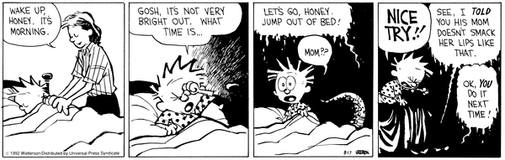

Figure 1
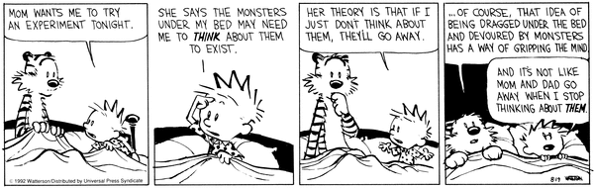

Figure 2
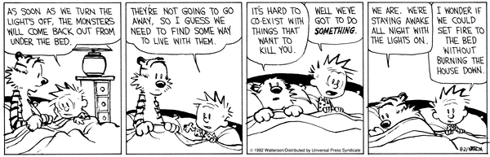

Figure 3
Works Cited:

Watterson, Bill. Exploring Calvin and Hobbes, Andrews McMeel, 2014.
Watterson, Bill. “Some thoughts on the real world by one who glimpsed it and fled.” Keynon Class of 1990 Graduation Ceremony, 20 May 1990, Kenyon College, Gambier, OH. Commencement Speech.
Watterson, Bill. The Complete Calvin and Hobbes, Andrews McMeel, 2012. Volume 1, 6-18; 3, 312-313.

